**Import the Test Cases from Excel**

**You need to have you Excel add in in your ALM**

**Then ALM icon will be located in your excel sheet**

**Click on it sign in**

**Then you need to do mapping and validation to make sure your description of columns are same as ALM**

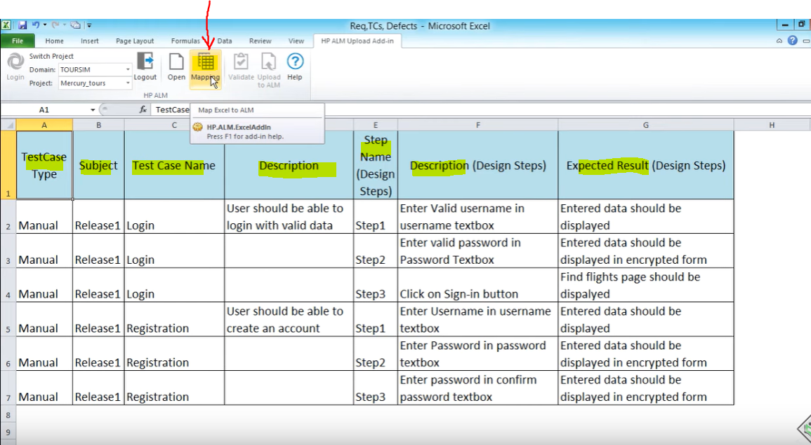

Select your entity type: Tests

Select your ALM Fields: …. then Click arrow to add

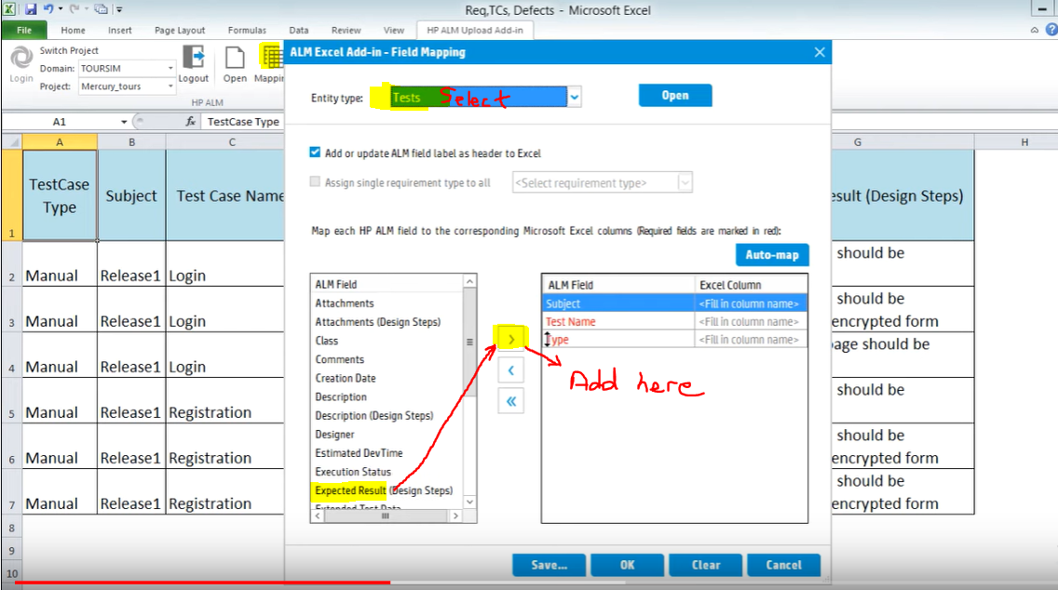

Or Click on Auto Map and let ALM figure it best it can and

You fill whatever excel can’t figure

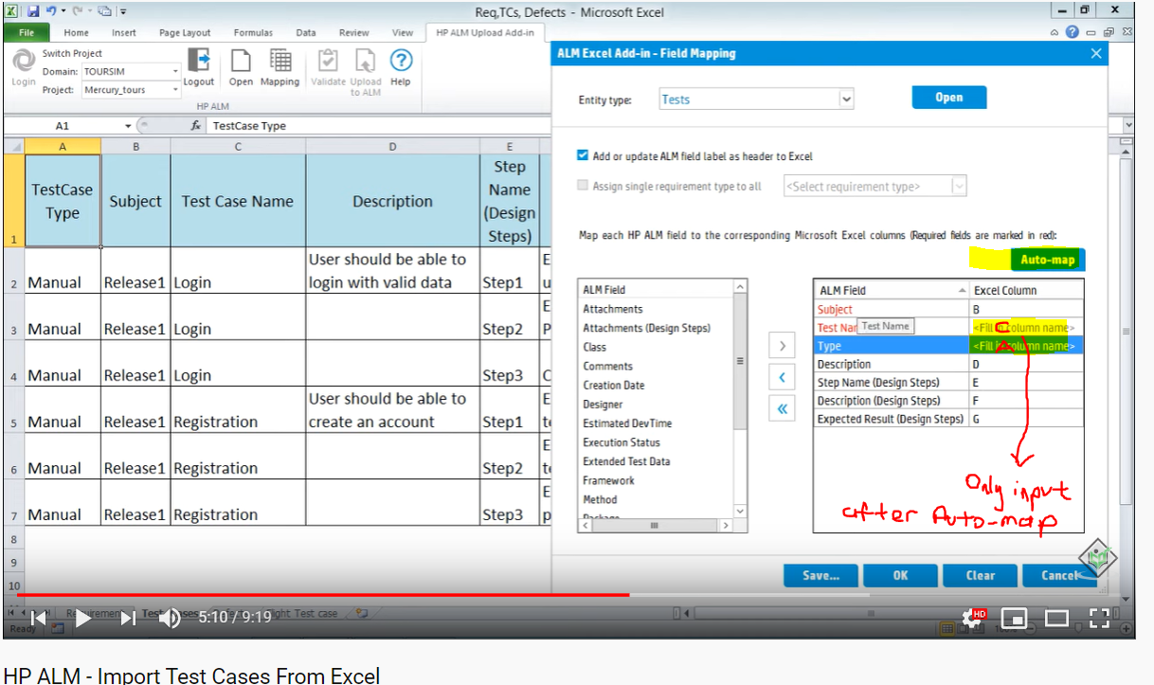

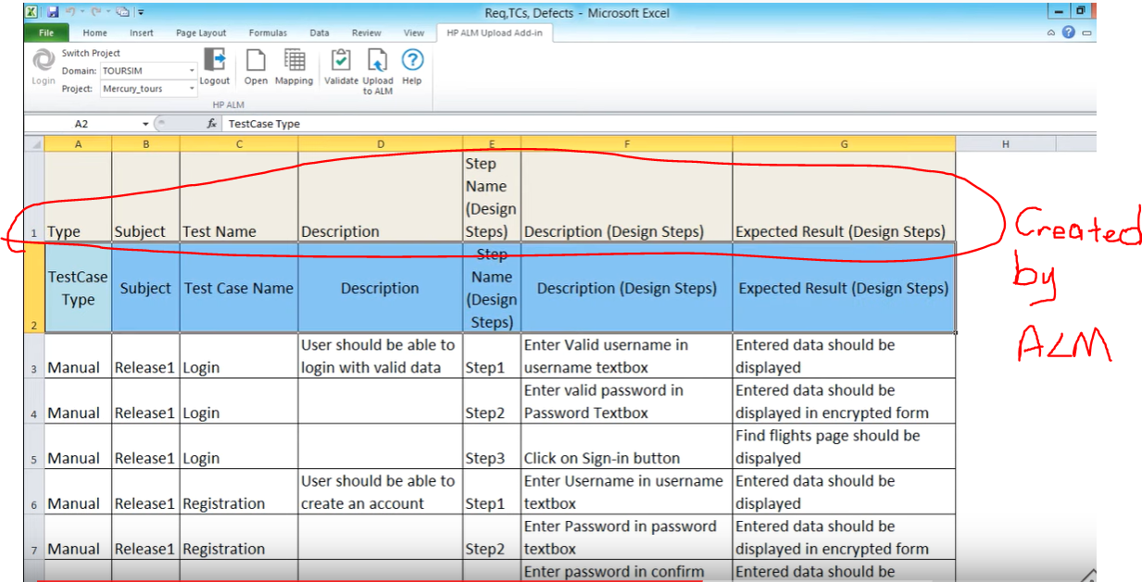

Now Its time to validate the inputs to make sure its same as ALM

So, select the only the data and click on validate

It’ll tell you if there is any wrong input

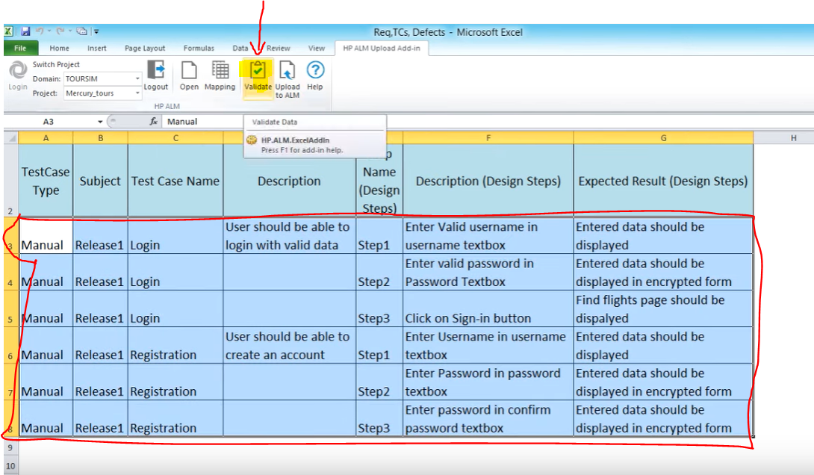

Then select it again and click on upload to ALM

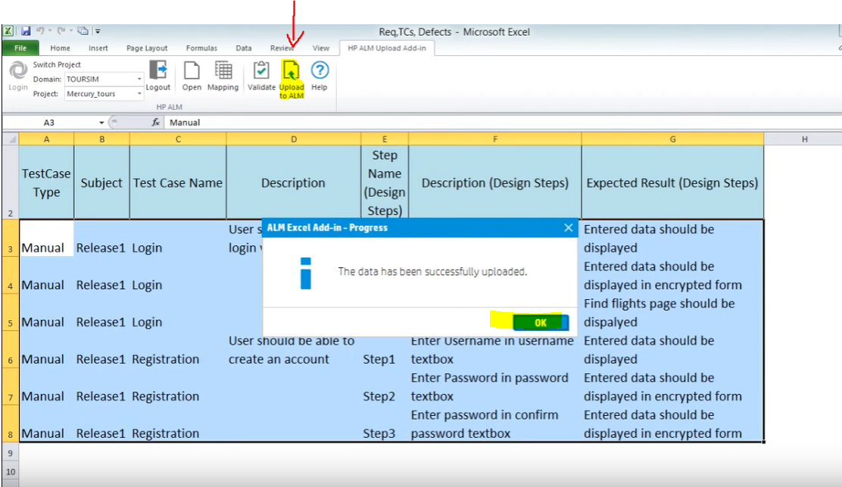

Subject is the folder name (Release1) in test plan module

